Standard | Items:
1.NBT.04 -  Add within 100, including adding a two-digit number and a one-digit number, and adding a two-digit number and a multiple of 10, using concrete models or drawings and strategies based on place value, properties of operations, and/or the relationship between addition and subtraction; relate the strategy to a written method and explain the reasoning used. Understand that in adding two-digit numbers, one adds tens and tens, ones and ones; and sometimes it is necessary to compose a ten. | 3.0  Solve and show your work.  1a. 12+5 =  1b. 7+6=  1c. 15+20=  The ‘2 set are extra questions if needed to pull from. We need only one set of each example of the standard.  2a. 13  - 4  _____  2b. 35  - 9  _____  2c. 27  +10  ____  Solve.  3a. 2 tens + 3 tens = _______ tens 3b. 20+30=________
2.0 Solve and show your work.
Strategy Bank: (WE NEED A VOLUNTEER TO INSERT VISUALS FOR STRATEGIES)
Count on Ones
Add Tens and Ones
Add Tens and Ones with Regrouping
Make a Ten
(Students can use Base Ten Blocks to solve.)

- 21+3=
- 18+5=
- 15+10=
- 8+8=
- 2 tens= _______ 3 tens= _______
- 20+30=_______
1.MD.02 -  Express the length of an object as a whole number of length units, by laying multiple copies of a shorter object (than the length unit) end to end; understand that the length measurement of an object is the number of same size length units that span it with no gaps or overlaps. | 3.0  **Be sure you specifically teach using examples measuring has no gaps and how measuring with gaps is incorrect.  Sam and Kate measured the paintbrush.  Sam 4 cubes Kate 9 cubes  Who measured correctly? _______________  Explain why.  __________________________________________________  - John used cubes to measure his pencil. John says it is 4 cubes long. Did John measure correctly? Explain how you know.  ____________________________________________________________________________________________________________________________________________________________________________________________________________________________  2. Draw a line that is about 5 cubes long.  2.0  1. About how many cubes long is this marker?  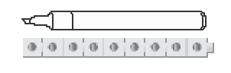  ____________ cubes  2. Tasha wants to measure the eraser. Which object would be best to use? Why? (INSERT IMAGE HERE)  A penny a pencil a book  ______________________________________________________  ______________________________________________________  ______________________________________________________
Use to measure
About ________
2.
About ________

3. 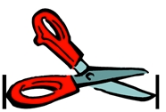

Circle about how many cubes long are the scissors?

2 cubes 20 cubes 7 cubes
1.MD.03 -  Tell and write time in hours and half-hours using analog and digital clocks. | 3.0  1. What time does the clock show? Circle the answers below.  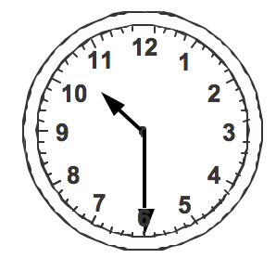  10 30  6 00  9 30  2. Draw the hands to show 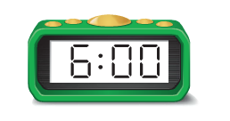on the analog clock below.  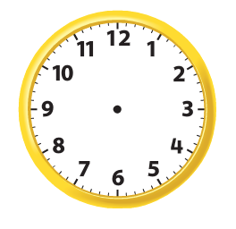  3. What time does the clock show?  (Insert Image)
2.0

1. Circle the digital clock.

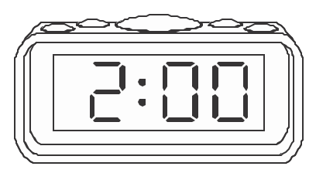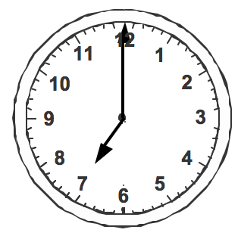

2. Write the time on the digital clock.
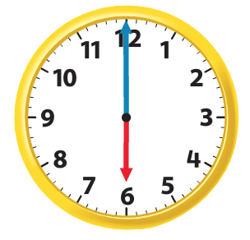
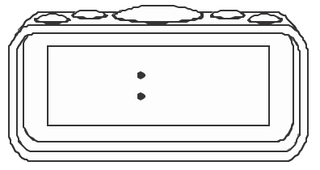

Possible questions as prerequisite:

Circle the hour hand and mark an X on the minute hand. PIC

- Circle the analog clock. Put an X on the digital clock. PIC
- Circle the clock that shows the minute hand on the half hour.PIC

- Circle the clock that shows 2 o’clock. PIC
B. Circle the clock that shows half past 2.

5. How many minutes are in 1 hour?

_________ minutes

6. How many minutes are in a half hour?

_________ minutes

